INTRODUCTION
Ocean acidification, one of the more insidious changes to accompany global climate change, is expected to affect all ecosystems at an accelerating pace over the next century (IPCC 2007; Caldeira and Wickett 2003). Many of the projected changes will have significant consequences for natural populations, from molecular physiological changes to broad-scale range shifts (Talmage and Gobler 2011; O’Donnell et al. 2009; Wong et al. 2011; Tomanek et al. 2011; Banks et al. 2010; Perry et al. 2005). Ocean acidification occurs as atmospheric anthropogenic CO₂ reaches equilibrium with ocean surface waters and more H⁺ ions are released into the water. The increase in H⁺ ion concentration in seawater is the direct cause for decreased pH (acidification); however, other changes resulting from this same chemical reaction may also have significant effects on aquatic organisms. Increased CO₂ concentration in seawater can change the gradient between an organism’s internal fluids and its environment, resulting in a greater diffusion of CO₂ into animal tissues (Fabry et al. 2008). Increases in internal CO₂ concentrations can result in acidosis of metabolic fluids, as seen in the cuttlefish Sepia officinalis (Gutowska et al. 2010), the sea urchin Psammechinus miliaris (Miles et al. 2007), and the mussel Mytulis edulis (Michaelidis et al. 2005).
Aquatic invertebrates, when compared to vertebrates, are generally more limited in their physiological resources that can be employed to combat environmental change and may therefore be especially susceptible to changes such as ocean acidification. In particular, acidification-induced changes can lead to inhibited calcification or shell dissolution and alterations in ion balance. The dissolution of CO₂ in seawater not only produces more H⁺, it also produces greater concentrations of bicarbonate (HCO₃⁻) and makes carbonate ion (CO₃²⁻) less available. The latter effect is of great importance to calcifying organisms since they rely on the availability of CO₃²⁻ to form and maintain carbonate-based structures (Beniash et al. 2010; Thomsen and Melzner 2010). Many aquatic invertebrates dissolve their calcified structures to make HCO₃⁻ more available as a buffer against internal acidosis caused by ocean acidification. This phenomenon has been observed across a range of shell-forming invertebrate species: the oyster Crassostrea gigas (Lannig et al. 2010), the limpet Patella vulgata (Marchant et al. 2010), and the urchin Psammechinus miliaris (Miles et al. 2007).
Stresses induced by ocean acidification can have secondary effects on organismal growth, physiology, behavior, and life history. Typically, invertebrate larvae that are reared at higher pCO₂ (partial pressure of CO₂) are smaller and have more developmental abnormalities than those at ambient pCO₂ (Chan et al. 2011; Parker et al. 2010). A host of physiological changes are also associated with changes in pCO₂. Invertebrate larvae raised at elevated pCO₂ show an inhibited ability to launch a heat shock response (O’Donnell et al. 2009) and alterations in both transciptomic and proteomic profiles (Todgham and Hofmann 2009; Wong et al. 2011; Stumpp et al. 2011). Urchin larvae (Strongylocentrotus purpuratus) reacted to ocean acidification through changes in expression of genes involved in acid-base balance, ion regulation, biomineralization and skeletogenesis, cellular stress response, metabolism, and apoptosis (Todgham and Hofmann 2009; Stumpp et al. 2011). In larval barnacles (Balanus amphitrite), Wong et al. (2011) detected changes in expression of proteins involved in respiration, energy metabolism, endocytosis, cell matrix degradation, and cellular stress. These physiological changes suggest that ocean acidification has negative and potentially long-lasting effects on invertebrate species.
Sustained environmental change, such as ocean acidification, can negatively affect both the ecosystem and economy through its effects on species such as the Pacific oyster. Oysters are ecologically important because they increase water quality through filter feeding and form reefs that create habitat for a myriad of other estuarine organisms. Molluscs are the secondmost important aquaculture group worldwide (13.1 million tons, 64.1% of global aquaculture production), with oysters making up 31.8% of total production (FAO 2010). Recently, in the Pacific Northwest of the U.S., there has been increasing concern over the already apparent effects of corrosive, acidified water on both natural and hatchery production of C. gigas larvae (Feely et al. 2010).
This study characterized the effects of two elevated levels of pCO₂ on size, calcification and physiology during early larval stages of the Pacific oyster, Crassostrea gigas. C. gigas larvae were raised in two elevated levels of pCO₂ (700 and 1000 µatm) and ambient (400 µatm) seawater from fertilization through four days post-fertilization. During this time, the larvae were assessed for size, calcification, and physiological response to ocean acidification through use of gene expression assays.

METHODS
Seawater chemistry manipulation
Experimental conditions were obtained using a seawater flow-through system in Friday Harbor, Washington, USA. Once the water entered the system, it was filtered (0.2 µm), UV sterilized, and CO₂ was depleted using membrane contactors (Membrana, Charlotte, NC, USA) under partial vacuum. Three experimental treatments were chosen to correspond with dissolved CO₂ levels of 400, 700 or 1000 ppm in the atmosphere. These levels correspond to current ambient conditions, projection for mid-century pCO_{2,} and end-of-century pCO₂, respectively (IPCC 2007). These three treatments will be referred to throughout the manuscript as Ambient, MidCO₂, and HighCO₂. Set-point pH levels were determined with the program CO₂SYS (Robbins et al. 2010) using an average alkalinity of 2060 µmol kg⁻¹ based on total alkalinity measurements over a week shortly before the start of the experiment.
Larval C. gigas were held 3 L microcosms, contained in a larger reservoir filled with respective treatment water. Ambient air stripped of CO₂ by a CO₂ adsorbtion unit (Twin Tower Engineering, Broomfield, CO, USA) was used to aerate the seawater within the reservoirs. This replaced oxygen lost through the degassing process. Reservoir pH was continuously monitored by a Durafet III pH probe (Honeywell, Morristown, NJ, USA) and pure CO₂ (Praxair, Danbury, CT, USA) was added to each system by a Honeywell UDA2182 pH controller in order to maintain pH in the three systems.
Seawater was pumped from the reservoir into larval microcosms through irrigation drippers (DIG Industries, Sun Valley, CA, USA) at a rate of 1.9 L per hour. An outflow tube at the top of the microcosms fitted with 35 µm mesh allowed water to exit the microcosms while retaining larvae. All systems were equilibrated to the correct treatment level 48 hours prior to the start of the experiment. Water temperature was 20.4°C ± 0.4°C

Oysters
Fourteen adult C. gigas, ten females and four males, were collected from Argyle Creek in Friday Harbor, WA in July 2011. Oysters were strip spawned with eggs and sperm pooled separately (day zero). Pooled eggs (approximately 2 million) were divided equally into 18 7.5cm diameter containers. Sperm was diluted in ambient seawater and added to each container of eggs. After sperm addition, the eggs were gently agitated and incubated for 15 minutes to allow for fertilization.
Six containers of fertilized eggs were transferred to microcosms containing one of three treatment conditions. Initial densities were approximately one larva mL⁻¹. On days one and three post-fertilization, larvae were randomly sampled to determine size and degree of calcification (see Table 1 for sampling protocol). For each microcosm sampled, larvae were filtered onto 35 µm mesh screens and washed. Approximately 100 larvae were removed from each tube. These 100 larvae were relaxed with 7.5% MgCl₂ and fixed in 4% paraformaldehyde buffered in filtered seawater. The remaining larvae were returned to cleaned microcosms filled with new seawater. The larvae were fed Dunaliellia sp. and Isochrysis sp. at concentrations of 30,000 cells mL⁻¹ each on days two and four post-fertilization. For feeding, water flow was turned off in microcosms for two hours. All microcosms were cleaned at each sampling event.
Larvae were examined using light microscopy to determine size, developmental stage and degree of calcification. Larval hinge length and shell height were measured at 10x magnification with a Nikon Eclipse E600 and NIS Elements Basic Research software (Nikon, Tokyo, Japan). Larval developmental stage and calcification were determined at 20x magnification using an inverted microscope and double polarized light for calcification. Larvae were scored as calcified on day one post-fertilization if calcification was observed at the hinge. On day three post-fertilization, larvae were classified as fully calcified if polarized light produced a “maltese cross” in the larval shell (Figure 1; LaBarbera 1974).
On day four, two microcosms from each treatment were sampled for later quantitative PCR analysis. The larvae were spun at 2,500 rpm for one minute at room temperature. The seawater was drawn off and the larvae were immediately flash frozen in liquid nitrogen.

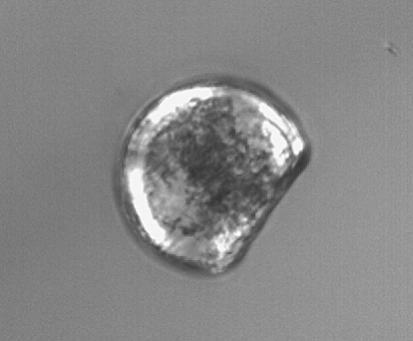
Figure 1. Fully calcified D-hinge C. gigas larva revealing a maltese cross under polarized light.
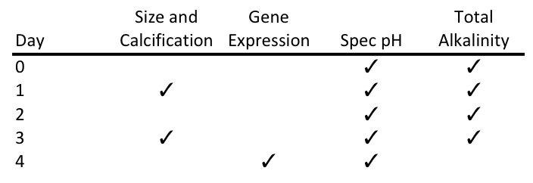
Table 1. Experimental sampling protocol for biological and chemical samples. C. gigas larvae were sampled for size and calcification on days one and three and for gene expression on day four. Spectrophotometric (spec) pH was measured on all days of the experiment. Total alkalinity was measured on days zero through three.

Carbonate chemistry
Throughout the experiment, salinity was measured with a conductivity meter (Hach sensION5; Loveland, CO, USA) and temperature was measured using a Fluke 1523 thermometer (Fluke, Everett, WA, USA). Seawater pH of the water entering the microcosms was measured daily using the spectrophotometric (spec) technique outlined in SOP 6b by Dickson et al. (2007) to confirm pH measurements from the Durafet probe. When any discrepancies were observed, the probe was recalibrated. Seawater pH measurements were randomly taken from two microcosms per treatment on days zero, one, and three. Final pH values reported here have been corrected for dye addition and temperature. Total alkalinity (A_{T}) was measured following the open cell titration of SOP 3b (Dickson et al. 2007). Samples for A_{T} were taken from incoming water for two microcosms in each treatment and on days zero, two, and three. CO₂SYS (Robbins et al. 2010) was used to calculate calcium carbonate saturation state (Ω) of aragonite and calcite and pCO₂ with A_{T} and pH as inputs using the following constants: Lueker et al. (2000) for CO₂ Constants, Dickson (1990b) for KHSO₄, Total scale (mol/kgSW) for pH scale, and Wanninkhof (1992) for Air-Sea Flux.

RNA extraction and qPCR
Total RNA was extracted from larvae collected on day four using Tri-Reagent (Molecular Research Center, Cincinnati, OH, USA). RNA (0.3 µg) was reverse transcribed using M-MLV reverse transcriptase and oligo dT primers according to the manufacturer’s protocol (Promega, Madison, WI, USA). Primers were designed to span intron-exon boundaries using Primer3 (Rozen and Skaletsky 2000) in Geneious Pro v. 5.3.6 (Drummond et al. 2010). Primer sequences are in Table 1. Quantitative PCR (qPCR) was performed using 1 µL of cDNA in a 20 µL reaction containing 10 µL of 2x SsoFast Eva Green Master Mix (Bio-Rad, Hercules, CA), 8 µL of nuclease-free water, and 0.5 µL each of 10 µM forward and reverse primers (Integrated DNA Technologies, Coralville, IA, USA). Thermal cycling and fluorescence detection were performed using a CFX96 Real-Time Detection System (Bio-Rad). Cycling parameters were as follows: 98°C for 2 minutes; 40 cycles of 98°C for 2 seconds, 55°C for 5 seconds plus a plate read; melt curve from 75-95°C at 0.2°C for 10 seconds, followed by a plate read. All qPCR samples were run in duplicate.
Average Cq (fluorescence-based quantification cycle) values across replicates and average gene efficiencies were calculated with PCR Miner (Zhao and Fernald 2005, http://www.miner.ewindup.info/version2). Gene expression (R₀) was calculated based on the equation R₀ = 1/(1+E)^{Cq}, where E is the average gene efficiency and Cq is the quantification cycle for fluorescence averaged across replicates. All expression values were normalized to expression of elongation factor 1α (GenBank Accession Number AB122066).

Statistics
Larval size was analyzed using an ANOVA with fixed effects of treatment and day, followed by Tukey’s Honestly Significant Difference test (Tukey’s HSD) when the ANOVA showed significant differences. A one-way ANOVA was also done on the larval size with the combined fixed factor of day-treatment. Larval calcification and developmental stage were compared between treatments using a generalized linear model (GLM). Binomial error distributions were used for all GLM analyses. GLMs assess the difference between groups while maintaining robustness to variable sample sizes. Differences in gene expression between treatments were calculated using ANOVA with treatment as a fixed effect. All analyses were performed in R (R Development Core Team 2011).

RESULTS
Carbonate chemistry
Throughout the experiment, pH was different between the three treatments, while A_{T} varied with natural fluctuations in the local water, though stable across treatments (Table 2). Seawater pH varied with average pH consistent with treatment set-points (Figure 2). In the Ambient treatment (target pCO₂ of 400 ppm), the average pH was 7.99 from as measured by the Durafet pH probes (Figure 2). The average pH in the mid-century projection treatment (MidCO₂) was 7.75 pH units and the HighCO₂ average pH was 7.66. Aragonite and calcite saturation states were greater than 1 for the duration of the experiment, except in the HighCO₂ treatment on days one and two (Table 2). Partial pressure of CO₂ in the seawater averaged 468 µatm across all five days for the Ambient treatment, 847 µatm for the MidCO₂, and 1065 µatm for the HighCO₂.
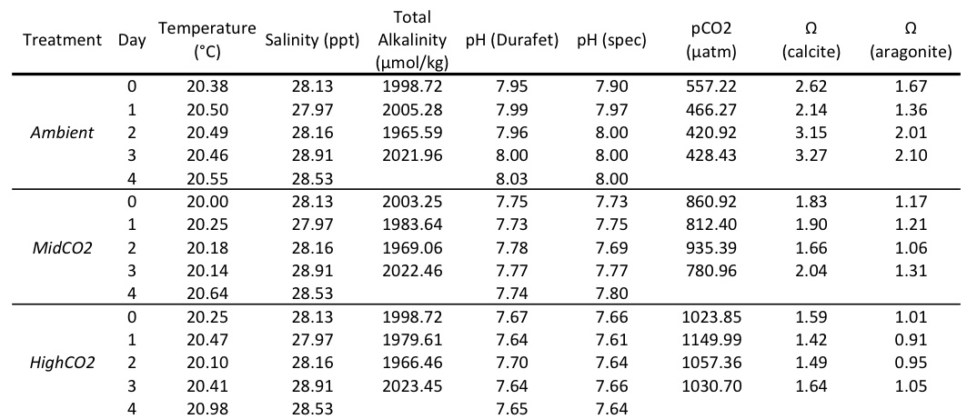
Table 2. Water chemistry data for all three treatments – Ambient, MidCO₂, and HighCO₂ experimental treatments. Temperature and Durafet pH measurements are averages from each day based on the Honeywell controller logs. Salinity, total alkalinity (A_{T}), and spectrophotometric (spec) pH are point measurements that occurred each day. Partial pressure of CO₂ and Ω are calculated from spec pH and A_{T}.
Figure 2. Profiles of pH monitoring in the three different treatments – Ambient (black), MidCO₂ (light gray), and HighCO₂ (dark gray). Average pH for the experiment for each treatment is represented by solid lines. The Durafet probes took pH measurements every minute.

Size, development, and calcification
Shell size, measured by both height and hinge length, was significantly different between days one and three and between treatments (Figures 3 and 4). The ANOVA was significant for a difference in shell hinge length across treatments (F= 8.937, p=2.93e-4) and between days (F= 1481.7, p=3.31e-5). Based on Tukey’s HSD, hinge length was significantly different in every pairwise comparison between treatments except between Ambient and MidCO₂ (Table 3). On day one, there was no difference in hinge length or shell height across treatments (p > 0.5 for all). On day three, the larvae at Ambient and at MidCO₂ were larger than those at HighCO₂ in terms of both hinge length (p=0.0311 and p=4.08e-5, respectively) and shell height (p=2.20e-6 and p=0.0311, respectively). There was no difference between Ambient and MidCO₂ for either hinge length (p=0.565) or shell height (p=0.261) on day three.
The larvae did not demonstrate any differences in rate of development between treatments through day three. On day one, a slightly greater proportion of larvae at HighCO₂ were at the D-hinge stage (compared to those that were still trocophores), but this difference was not significant (z-value=1.016, p=0.310; data not shown). By day three, all larvae observed across treatments were at the D-hinge stage (in a comparison between treatments z-value=1.55e-4, p=1).
Larval calcification was significantly different between treatments for days one and three post-fertilization. On day one post-fertilization, calcification was greater in the HighCO₂ treatment (z-value=2.084, p=0.0372, Figure 5). On day three, the trend had switched and the larvae at HighCO₂ were significantly less calcified than the other two treatments, which had similar numbers of fully calcified larvae (z-value=-3.203, p=0.00136).
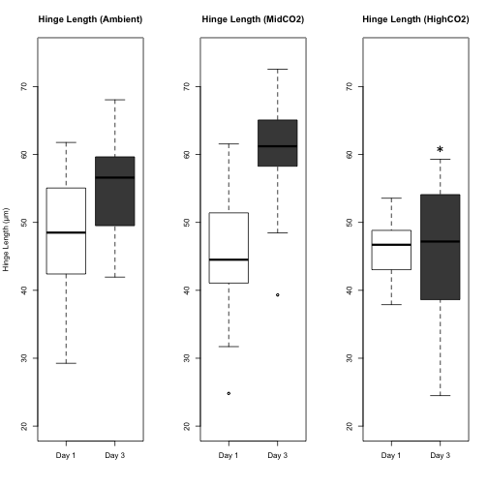

Figure 3. Larval hinge length by and day (boxplots corresponding to day one are white and those for day three are gray). The boxplots contain the middle 50% of the data and the bars extending from the plots encompass the data within 1.5 times the spread of the middle 50%. The open circles beyond the bars are outliers. The horizontal black bar in the plots is the median value of each data set. Larvae at HighCO₂ did not grow significantly from day one to day three and were significantly smaller than the other two treatments on day three (marked by an asterisk).

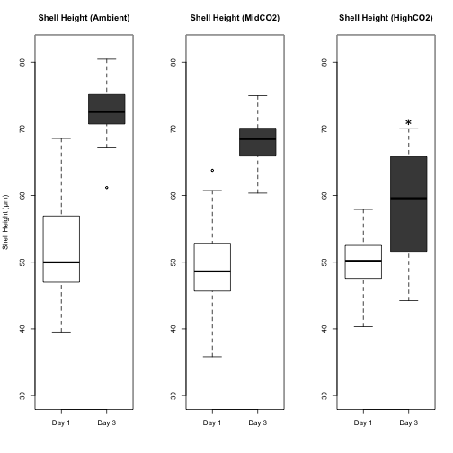
Figure 4. Larval shell height by treatment and day (boxplots corresponding to day one are white and those for day three are gray). The boxplots contain the middle 50% of the data and the bars extending from the plots encompass the data within 1.5 times the spread of the middle 50%. The open circles beyond the bars are outliers. The horizontal black bar in the plots is the median value of each data set. On day three, larvae at HighCO₂ (marked with an asterisk) had shorter shell height than the controls raised at Ambient.
Figure 5. Proportion of larvae calcified, by treatment, at one and three days post-fertilization. The bars representing calcification on day one are white; those representing day three are gray. There is a significant difference in calcification between treatments, with the highest proportion larvae calcified at HighCO₂ on day one and the fewest larvae calcified in the same treatment on day three.

Gene expression
Genes were expressed…somehow….stay tuned!

DISCUSSION
C. gigas larvae are able to tolerate moderate acidification in early development, but the impacts of exposure to more extreme acidification are reflected in significant differences in larval size and calcification by day three post-fertilization. A pCO₂ of 847 ± 67 µatm (MidCO₂) did not affect growth or calcification of larval oysters when compared to Ambient pCO₂ of 468 ± 63 µatm. However, larvae raised at an additional 200 µatm of pCO₂ (HighCO₂, 1065 ± 58 µatm) were both significantly smaller and less calcified by day three post-fertilization. C. gigas’s physiological plasticity at this developmental stage is exceeded between the Mid- and HighCO₂ treatments. The chemistry scenarios simulated in this study are based on projections for the coming century, but these values of low pH and Ω are already occurring with increasing frequency in the nearshore waters off the U.S. West coast (Feely et al. 2010; Plattner et al. 2009), which is habitat to C. gigas and many similar species.
C. gigas larvae were smaller in the HighCO₂ treatment compared to both Ambient and MidCO₂ through day three post-fertilization, but did not show evidence of a developmental delay. There is an energetic advantage to maintaining a smaller size in a stressful environment since less energy allocated towards growth means that more energy is available to counteract the stress. However, the smaller size of larvae at higher pCO₂ could lead to disadvantages. Smaller veliger larvae are not able to feed as efficiently as larger ones (Strathmann and Leise 1979). Larval sand dollars, Dendraster excentricus, responded to increased pCO₂ (pH of 7.75) through changes in morphology that resembled a starvation response without the usual compensation of longer arms that allow for greater food capture (Chan et al. 2011). The exposure to ocean acidification altered the larval ciliary beat pattern, thus decreasing the efficiency of particle capture, leading to decreased stomach size (Chan et al. 2011). C. gigas larvae also depend on ciliary movement for feeding, although the direct effects of ocean acidification on this mechanism are unknown. It is impossible to determine from this study if decreased ability to acquire food or less available energy for growth is the main cause for stunted larval size, but these combined impacts of ocean acidification could have additive or multiplicative effects on larval growth.
An altered energy budget leading to decreased size, less calcification, and developmental delay at elevated pCO₂ could potentially be the greatest impact of ocean acidification on marine invertebrate larvae (Crim et al. 2011; Yu et al. 2011; Kimura et al. 2011; Parker et al. 2010; Dupont et al. 2008; Stumpp et al. 2011). Ocean acidification changes ion balances across membranes, leading to an increased energy demand in organisms as they correct the imbalance or as they launch a stress response in reaction to it. Changes in ionic concentration due to hypercapnia and calcified structure dissolution can result in overall shifts in cellular ion gradients, which could significantly alter cellular processes (Dissanayake et al. 2010). Overall, changes in environmental and internal organismal carbonate chemistry create a more stressful and energetically demanding environment for aquatic invertebrates.
Within the first 24 hours post-fertilization, C. gigas larvae calcified at a greater rate under the highest pCO₂. This anomaly may be an attempt by the larvae to protect themselves against a hostile environment. If the acidification event had been transient, as they frequently are in near-shore upwelling systems, more calcification at an early stage may have ensured that the larvae would have some shell left once the acidified water passed. When the environmental stress proved to be permanent, the larvae could no longer maintain the excess energy investment and their growth and calcification fell behind those of the larvae raised at lower pCO₂ levels.
The aragonite saturation state (Ω_{Ar}) was considerably different in the HighCO₂ treatment and this carbonate chemistry alteration may have played a significant role in the decreased size and calcification of the oysters. The Ω of both calcite and aragonite was never greater than 2.0 and Ω_{Ar} (the polymorph of CaCO₃ that is used the most in larval shells at his stage) was at or below 1.0. This particular carbonate chemistry parameter most likely contributed to the decreased size and calcification in the HighCO₂ treatment. Increasing attention is being put on the importance of changes in Ω and how it affects larval growth and development. C. gigas larval survival and mid-stage growth in the hatchery were impacted by decreased Ω_{Ar} when exposed during spawning (Barton et al. in review). C. gigas larvae exposed to different ocean acidification scenarios after fertilization demonstrated decreased viability, size and calcification only when Ω_{Ar} was low, irrespective of pCO₂ level (Gazeau et al. 2011). Even short-term exposure to decreased Ω_{Ar} during vulnerable developmental periods can adversely affect later larval stages (Barton et al. in review).
The potential for local adaptation during climate change may prove to be the key to population persistence of C. gigas and similar species. As broadcast spawners, individual C. gigas can produce thousands of larvae with each reproductive effort. Within a population, the proportion of larvae that survive is determined in part by chance (sweepstakes selection; Hedgecock 2007) and in part by having the genotype that is fit in the contemporary environment. Thus, broadcast spawners have the life history potential to both acclimatize and adapt to environmental change. If planktonic larvae have a long enough larval period so that the spatial scale of gene flow is greater than the scale of the selective gradient, then post-settlement purifying selection within each generation can maintain overall population genetic diversity (Sanford and Kelly 2011; Somero 2010). Maintenance of this diversity could provide the genetic resources necessary for future adaptive responses during climate change. This genetic diversity could be maintained as long as wild populations are not exposed to a strong selection pressure that encompasses a similar range as their gene flow. This selection pressure could take the form of a single significant event or could be caused by co-occurring multiple stressors.
Ocean acidification is a current and future challenge and will continue to negatively impact aquatic organisms. These impacts are of both ecological and economic concern since the effects of ocean acidification are seen across taxonomic groups (i.e. on an ecosystem-level scale) and have the potential to decrease the viability of commercially important populations. This research contributes to the growing evidence than ocean acidification has the ability to reduce the viability of marine invertebrate larvae. However, given the wide range of genotypes that arise from broadcast spawning events every generation, there is the possibility for acclimatization and adaptation over time for C. gigas and similar species. Further studies that investigate genotype-dependent survival under future climate change scenarios will help to determine if ocean acidification and associated climate shifts will prove to be surmountable selective pressures or harbingers of local extinction events.

Literature Cited
Perry, A.L., P.J. Low, J.R. Ellis and J.D. Reynolds. 2005. Climate change and distribution shifts in marine fishes. Science. 308:1912-1915.

Robbins, L.L., Hansen, M.E., Kleypas, J.A., and Meylan, S.C., 2010, CO2calc: A User-Friendly Carbon Calculator for Windows, Mac OS X, and iOS (iPhone): U.S. Geological Survey Open File Report 2010-1280, 42pp.

IPCC 2007; Caldeira and Wickett 2003
Talmage and Gobler 2011; O’Donnell et al. 2009; Wong et al. 2011; Tomanek et al. 2011; Banks et al. 2010; Perry et al. 2005
Fabry et al. 2008
Gutowska et al. 2010
Miles et al. 2007
Michaelidis et al. 2005
Beniash et al. 2010; Thomsen and Melzner 2010
Lannig et al. 2010
Marchant et al. 2010
Miles et al. 2007
Chan et al. 2011; Parker et al. 2010
O’Donnell et al. 2009
Todgham and Hofmann 2009; Wong et al. 2011; Stumpp et al. 2011
FAO 2010
Feely et al. 2010
Robbins et al. 2010
LaBarbera 1974
Zhao and Fernald 2005
Feely et al. 2010; Plattner et al. 2009
Strathmann and Leise 1979
Crim et al. 2011; Yu et al. 2011; Kimura et al. 2011; Parker et al. 2010; Dupont et al. 2008; Stumpp et al. 2011
Dissanayake et al. 2010
Gazeau et al. 2011
Barton et al. in review
Sanford and Kelly 2011; Somero 2010

